Lab 10 Results

Student: Diego Rosenberg de Angoitia

Net ID: dr3432

N#: N11409122

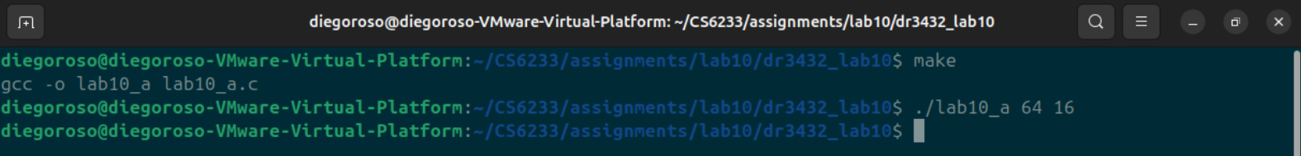

1. Observing the graph above we can see that the number of page faults seems to decline at a linear pace but the minimum number of page faults will always be the number of pages in the original code (since we always have to load them at least once). Since LRU is a stack based algorithm which will always prevent Belady's Anomaly and always looks to replace the “least used” frame, preventing more frames from resulting in more page faults.